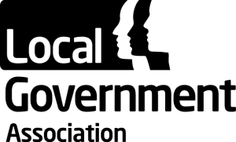

Appendix A: Draft Agenda

 | Title: Joint CWB/CYP workshop
 | Date: 8 January 2015 |  | Time: 14:00
 | Location: Smith Square 3&4
Item No. |  | Topic |  | Chair | Presented by
1 |  | Introduction |  | David Simmonds
2 |  | Children’s Public Health 0-5 Transition:  - Progress update  - Discussion on how the CYP and CWB Boards can support children’s services and health and wellbeing boards to transform and improve services for children across ages 0-19/25 |  | David Simmonds | Sally Burlington
3 |  | Children, adolescent and young adults’ mental health issues:  - Update on the LGA’s current work on children and adult’s mental health issues;  - Discussion on future work and how the CYP and CWB Boards can support this work programme going forward |  | Izzi Seccombe
4 |  | Discussion on future work relating to people with learning disabilities with complex needs: improving outcomes for and mapping the spending pressures across people’s lives. |  | David Simmonds
5 |  | Wrap up and summary of agreed tasks/actions |  | Izzi Seccombe

